

Terms of Reference
Department of Conservation – Te Papa Atawhai
Predator Free Kāhui Māori – Ngā Matapopore
Creation Date: [insert date]

Senior Responsible Owner
Project Sponsor / Manager
Project Code
Author
Version | 1

COMMERCIAL
Document Control

Document Information

Document Name
Status | Draft

1.2 Version History

Version | Date | Author | Nature of amendment
1.0 |  |  | Initial draft
2.0 |  |  | Second draft
3.0 |  |  | Final edits

1.3 Reviewers

Version | Date | Name | Role
1.0
2.0
3.0

1.4 Supporting Documents

Document | Version | Location
Remuneration Paper | 1.0 | TBC
Selection Assessment | 1.0 | TBC

Contents

1.1 Document Information 2
1.2 Version History 2
1.3 Reviewers 2
1.4 Supporting Documents 2

1 Purpose of this document 4

2 Ngā Matapopore 4
2.1 Purpose 4
2.2 Governance, Delegations and Deliverables 5
2.3 Membership and Tenure 5
2.4 Remuneration and Reimbursement of Expenses 7
2.5 Independent Advice 7
2.6 Conflicts of Interests 8
2.7 Confidentiality 8
2.8 Disestablishment 8

3 Acceptance of Terms of Reference 9

4 Appendices 9
4.1 Appendix 1 – List of Panel Members 9
4.2 Appendix 2 - Selection Criteria for Panel 9
4.3 Appendix 3 – Principles of Māori Data Sovereignty 11
4.4 Appendix 4 – Details of Agreed Deliverables 13

Purpose of this document
These Terms of Reference are the primary governing document for Ngā Matapopore, they:
- establish the Panel,
- explain the Panel’s purpose, scope and responsibilities,
- outline the role of its members and their responsibilities,
- explains the Panel’s working protocols, and
- provides disestablishing protocols.

Ngā Matapopore

Purpose
- Ngā Matapopore (the Panel) is an expert advisory group supporting the Department of Conservation – Te Papa Atawhai (DOC) ‘Predator Free 2050’ (Programme) programme and team.
- The Panel furthers DOC’s vision of bringing te ao Māori and mātauranga into its Predator Free 2050 work and research, by providing guidance, advice and recommendations on how to do that in an appropriate way and identify risks and opportunities that Programme participants should be cognisant of in their work in the Predator Free Programme.
- The Department of Conservation, ‘DOC’ established the Panel on [insert start date] to provide advice grounded in mātauranga Māori and Māori community interests, especially as it relates to the Predator Free 2050 programme.
- The topics or types of advice sought from the Panel may include:
  - Provide guidance, connections and oversight over …,
  - Guide distribution of the …,
  - Providing advice and guidance on the development of the …,
  - Identifying key communities of interest and holders of mātauranga related to similar research and operations,
  - Offering advice and direction to agencies, in the…, on Māori engagement, ensuring it aligns with Māori principles, perspectives and views,
  - Guiding Programme researchers and participants on:
    - Tikanga required for carrying out proposed research or work,
    - Use of mātauranga, Māori principles, perspectives, and or views in proposed research or work,
    - Giving effect to Te Tiriti o Waitangi in proposed research or work,
  - Identifying risks and opportunities that should be highlighted for co-leads, researchers, participants in the Programme,
  - Identifying further rangahau, monitoring and data needed to provide a robust and comprehensive mātauranga Māori evidence base, and Tiriti-centred decision-making framework for work in the Programme, and
  - Identifying strategic opportunities where mātauranga Māori should be resourced or given priority in decision-making or reporting in or across the Programme.
- Initially, the Panel will be effective from [insert start date] through to [insert end date #1]. The intent is that the Panel will continue past this date, subject to …. The Senior Responsible Owner may shorten or extend the Panel’s duration by amending these Terms of Reference and recording the extension with DOC’s procurement and legal team(s).

Governance, Delegations and Deliverables
- These Terms of Reference and DOC’s corporate policies govern this Panel.
- The Panel reports to the Senior Responsible Owner, who may make changes to these Terms of Reference as needed.
- The Panel does not hold any delegation and has no authority to make decisions or commit DOC to anything.
- Information about any specific deliverables agreed to by the Panel, including required resourcing, will be outlined in an agreed document that will be attached, via appendices to these Terms of Reference.

Membership and Tenure
- The establishment of the Panel will fulfil the commitment made in the Programme plan to ensure Māori, their knowledges and philosophies are included in the Predator Free Programme, especially in its research.
- As noted above (point 9) specific deliverables agreed to by the Panel will be outlined and attached to these Terms of Reference.
- The Senior Responsible Owner appoints the Panel, and its Chair (if required).
- Delegated DOC officials may also be appointed to, and or Chair the Panel. Their responsibilities will be the same as those of Panel members.
- The Panel is set up to ensure that as a whole it has the skills, knowledge and ability to fulfil its purpose and properly discharge its roles and responsibilities.
- The Panel was appointed, drawing upon advice from relevant DOC staff and external advisers. Criteria were developed to assist in the selection process for establishing the Panel membership.
- The Senior Responsible Owner will appoint five to eight members, on an ongoing basis, taking into regard the collective and individual expertise in mātauranga Māori of its members, as well as the diversity of their views and experience.
- Collectively, the Panel will possess expertise across mātauranga, science, policy and any other disciplines germane to the Programmes work.
- Each member of the Panel will hold office until 30 June 2024. Their membership may be renewed for a further term and in alignment with these Terms of Reference.
- A member of the Panel may resign at any time by written notice to the Senior Responsible Owner.
- A member of the Panel may be removed by the Senior Responsible Owner, for non-performance, including for missing two or more consecutive meetings without prior notification.
2.3.1 Chair’s responsibilities
- Should a Chair be appointed their responsibilities will include:
  - Work with the Panel’s secretariat to coordinate the Panel’s business and administration, including scheduling meetings, writing agendas and distributing papers and meeting notes,
  - Facilitating discussions during the meetings, encouraging and modelling open communication where all Panel members contribute effectively,
  - Ensuring members conflicts of interest are managed at every meeting, and
  - Liaising with the Senior Responsible Owner regarding the progress and performance of the Panel.
    - Member’s responsibilities
- Members will attend all meetings. If a member is unable to attend for any reason, they must notify the Chair or Secretariat with advanced written notice.
- Panel members are appointed in their personal capacity as independent experts, not as representatives of their organisations. Hence members may not send a delegate in their stead, except at the discretion of the Chair and Senior Responsible Owner.
- If a Panel member is unavailable for a meeting, he or she may provide advice on a topic via email – preferably prior to the meeting.
- Members may also be required to perform tasks or accept responsibilities, as required by the Panel’s purpose, including:
  - Contribute to all discussions amongst the Panel about relevant mātauranga and scientific issues,
  - prepare adequately prior to each meeting, review any papers provided prior to meetings and participate actively in meetings, contributing to actions when agreed,
  - bring matters of significance to the attention of the Panel and use professional perspectives to undertake analysis or prepare advice as required, and
  - provide feedback on draft minutes of meetings.
    - Administration
- The Panel will be supported by a secretariat comprised of staff from [insert organisation or team].
- The Panel’s Secretariat will:
  - meet with the Chair, coordinate all the Panel’s business and administration, including scheduling meetings and forming and distributing agendas,
  - record and distribute meeting minutes and actions to members for comment within five business days after the meeting,
  - circulate a meeting pack containing the agenda and any discussion papers at least one week in advance of each Panel meeting, and
  - keep the members interests register up to date.
- A quorum is required in order for the Panel to conduct business.
- The requirement for a quorum will be met if a majority of members attend.
- Members of other Programme groups may attend meetings by invitation to address specific topics on which their advice has been requested.
- The Panel will meet four times per annum, two meetings will be online and two will be in person.
- The Secretariat will provide members with notice of meetings at least two weeks before the next scheduled meeting. Notice of cancellation will be provided at least two days before the scheduled meeting.
- The duration of meetings is anticipated to be between 0.5 – 1 day long but will be agreed to by the Chair and Secretariat.

Remuneration and Reimbursement of Expenses
- All reasonable costs for travel and incidental expense costs will be met (where necessary) by DOC for Panel member participation.
- Members of the Panel, except the Chair are to be paid daily rates in accordance with DOCs corporate policies and or agreement with DOC legal and procurement teams.
- A standard meeting fee of $XX (plus GST) per member ($XXX for the Chair) per full-day meeting will apply and will include meeting preparation time.
- Work outside of this Panel will be negotiated with Panel members and subject to a contract for services agreement (or similar).

Independent Advice
- Panel members are expected to provide impartial, independent advice to DOC that reflects their best knowledge and judgement in their areas of expertise, that hold Mātauranga Māori at the centre.
- Panel members are not expected nor required to reach consensus on all matters or recommendations from the Panel. Where consensus is reached on a particular matter, topic, conclusion or recommendation, it will be noted as such in meeting minutes. Where consensus is not reached, the different points of view will be recorded anonymously in meeting minutes.
- Final decisions on advice, management and provision of funding, budgets and financial aspects of DOC’s Programme and the management of procurement processes remain the sole responsibility of DOC.

Conflicts of Interests
- All Panel members must ensure their advice to DOC does not seek to benefit any personal or commercial interests they or their employer may have in data or science-related projects.
- Panel members are required to formally declare any existing, potential or perceived conflicts of interest that arise so that these can be managed appropriately. This includes current or future services that advisers may commercially offer to DOC. Disclosure of conflicts can be self-initiated, raised by DOC, or raised by other members of the Panel.
- Conflicts will be reviewed by the Chair and Senior Responsible Owner, and they will decide if there is a relevant interest and determine appropriate action.

2.7 Confidentiality
2.7.1 Sensitive and Confidential Information
- Panel members may be required to sign non-disclosure and/or confidentiality agreements if the Panel asks and or agrees to review confidential information, including drafts of reports and briefings that are embargoed until official release dates. This information can be held in emails, meeting minutes, and draft products. Panel members will be required to treat all such information as sensitive and confidential.
- It is expected that Panel members may want to seek advice from colleagues or other experts in their professional networks, and DOC is in support of this. However, any individuals engaged outside of the Panel must first be identified to the Chair and if required sign a confidentiality agreement before they are provided any confidential information.
2.7.2 Intellectual Property
- “Intellectual Property” means all manner of intellectual property rights including (without limitation) patents, trademarks and service marks, logos, copyright, design rights and know-how whether registrable or not in any country but excluding mātauranga Māori.
- “Mātauranga Māori” in relation to Intellectual Property means any information identified as such by the Panel in accordance with applicable tikanga and kawa.
- The Panel may choose to operate under the principles outlined in Te Mana Raraunga Principles of Māori Data Sovereignty (refer to Appendix 3).

2.8 Disestablishment
- The Panel’s Chair will notify and seek approval from the Senior Responsible Owner to disestablish the Panel.
- Reasons for disestablishing the Panel include:
  - An inability of the Panel members to work cohesively as a group to meet their purpose as outlined in section 2.1 of these Terms of Reference.
  - A complete shift in the Programme direction such that the Panel is no longer required or supports the purpose of its establishment.

Acceptance of Terms of Reference
- In accepting these Terms of Reference, each member of the Panel:
  - agrees to provide advice to the Programme and DOC that reflects their best knowledge in their areas of expertise,
  - is able to participate constructively in the provision of the advice described, and will inform the Chair if they are unable to do so,
  - understands the sensitivity and confidentiality of Programme information that is not in the public domain and agrees to not disclose any confidential information without the consent of the Chair and Senior Responsible Owner; and
  - has disclosed any conflicts of interest, and if required signed a confidentiality agreement.

Appendices

Appendix 1 – List of Panel Members

 | Name | Organisation | Email
1
2
3
4
5
6
7
8
9
10

4.2 Appendix 2 - Selection Criteria for Panel

Criterion |  | Description
 | Pūkengatanga | Depth of mātauranga and/or scientific expertise in a relevant discipline and track record of its application in Aotearoa New Zealand.
 | Rangatahitanga | Youth perspective and expertise, future-focused.
 | Tūhonontanga | Ability to draw upon diverse local knowledge systems and advise from a systems perspective.
 | Rautakitanga | Strength in strategic and mokopuna decision-making frameworks, particularly advising on the intergenerational aspects of environmental change that are most impactful for Māori.
 | Mātauranga | Experience in the use of Mātauranga, data and evidence to inform policy or research development and evaluation.
 | Whānaungatanga | Strength and breadth of networks across the variety of Māori communities and with knowledge holders.
 | Māramatanga | General communication skills, particularly the ability to translate technical information and knowledge for a non-technical audience.
 | Mahi tahi | Collaboration skills, including active listening, facilitation, conscientiousness, and tolerance for working in a relatively fluid environment.
 | Rangatiratanga | Champion for change and change management, to move the system towards kaitiaki expressions of rangatiratanga.
 | Mana | Respected by others in the system: experience in comparable mātauranga advisory roles requiring impartiality and confidentiality, especially in relation to key science work programmes.

Appendix 3 – Principles of Māori Data Sovereignty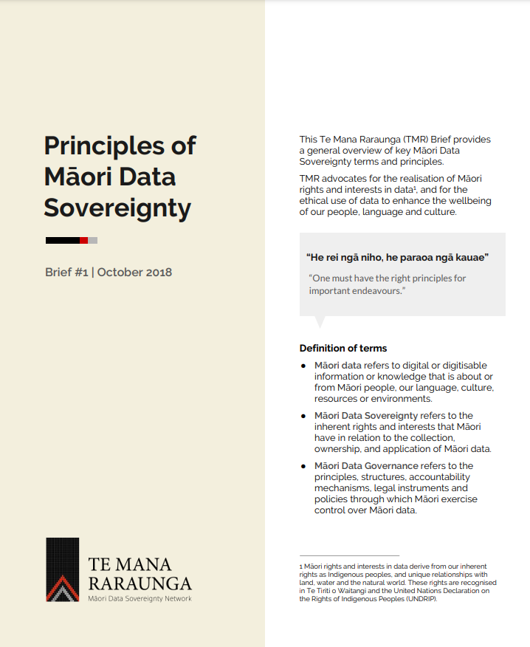
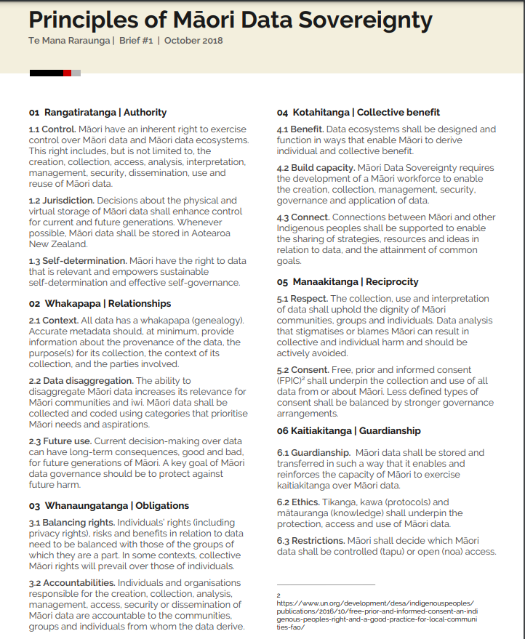

4.4 Appendix 4 – Details of Agreed Deliverables

Agreed Deliverable
Purpose:
- what priority in the Programme does this deliverable align with and why is it needed (why can’t the research team do it)?
- how does it align with the Panels purpose (section 2.1)?
- is it time constrained and if so, what is the period?

Scope and Deliverables:
- define what this Panel will deliver, and what is in scope and what is not.
- what are the tasks, activities and milestones that will be achieved to deliver on the purpose and objectives noted above.
- what is the timeframe for achieving each of the tasks, activities and milestones?

Membership and Responsibilities:
- Clearly define the role and responsibilities/expectations of each Panel member (example below):

Name | Role in Deliverable | Responsibility | Additional Information
e.g. Hone Smith – Panel member | e.g. Chair and expert mātauranga advisor | List any responsibilities specific to this task/deliverable that are in addition to the sections 2.3.1 and 2.3.2 of these ToR. | Note here additional information needed e.g. if a confidentiality agreement or contract for services is required.
e.g. Aroha Lovey – CRI staffer | e.g. CRI researcher | List any responsibilities specific to this task/deliverable that are in addition to the sections 2.3.1 and 2.3.2 of these ToR. | Note here additional information needed e.g. if a confidentiality agreement or contract for services is required.
e.g. Hemi Hohepa –  Co-opted external expert | e.g. Expert Māori science communicator | List any responsibilities specific to this task/deliverable that are in addition to the sections 2.3.1 and 2.3.2 of these ToR. | Note here additional information needed e.g. if a confidentiality agreement or contract for services is required.

